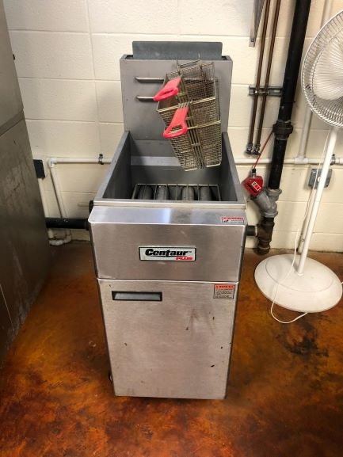

Surplus Fryer, natural gas, (deep fried food is not allowed in the food program)

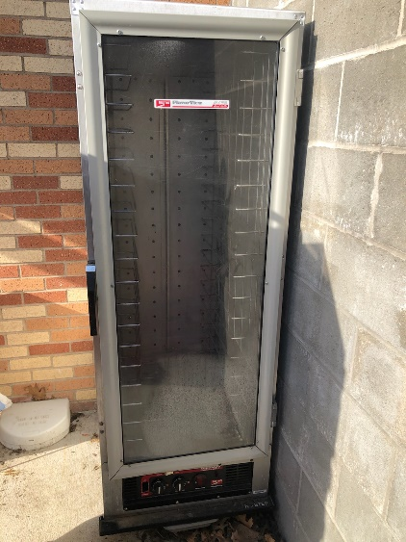

Surplus Electric Warmer, due to temperature issues. (Won’t keep food at serving temp)

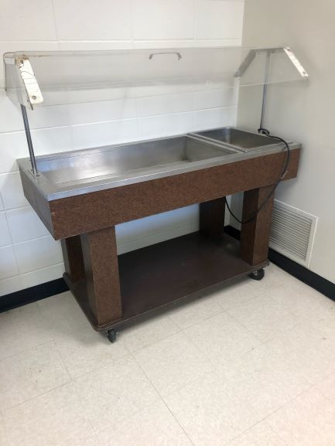

Surplus Salad Bar, Too small for breakfast use